ECONOMICS OF THE CRISIS - MICRO AND MACRO ASPECTS

Please follow the link to access the videos needed for each question.

https://www.tutor2u.net/economics/reference/economics-of-the-crisis-micro-and-macro-aspects-head-start-in-a-level-economics

- Video 1 is an introduction, and consolidates your learning on the difference between micro and macro. It also consolidates learning on sectors of the economy AND globalisation, as it shows how Primark having no sales has impacted the textile industry in Bangladesh. Take another industry affected by COVID and explain which OTHER industries it will have affected. Then explain which Country’s macroeconomy that would have affected, and how?

UK Industry affected:
UK Company affected:

Other Industry affected and why:
Other country whose macroeconomy would be affected and why:

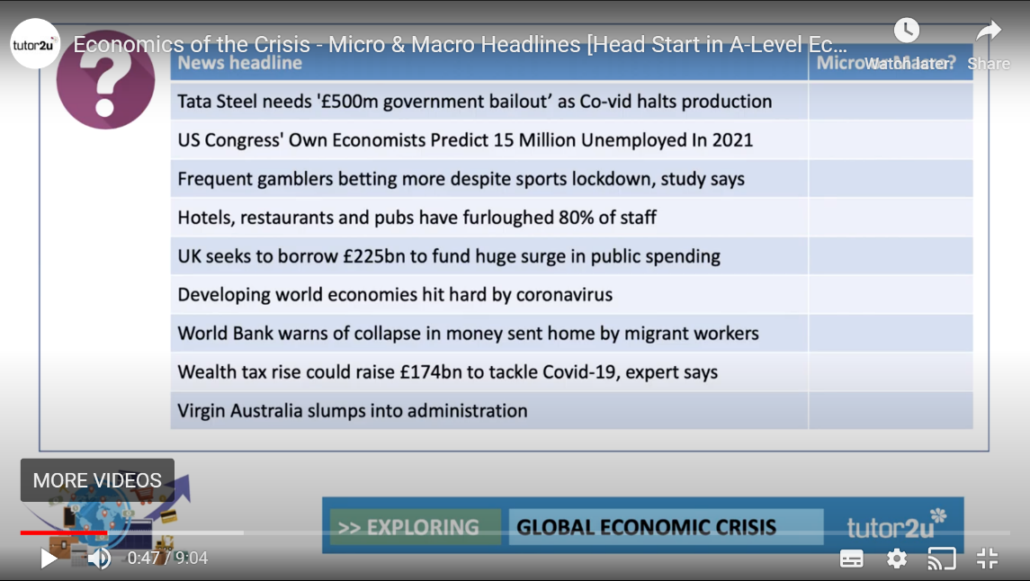
- Video 2 is about Micro and Macro - pause the video after 47 seconds and write down below whether you think each of the stories is micro or macro or both (but don’t sit on the fence!)?

Tata -
Congress -
Gamblers -
Hotels -
UK borrowing -
Developing countries -
World Bank -
Wealth Tax -
Virgin administration –

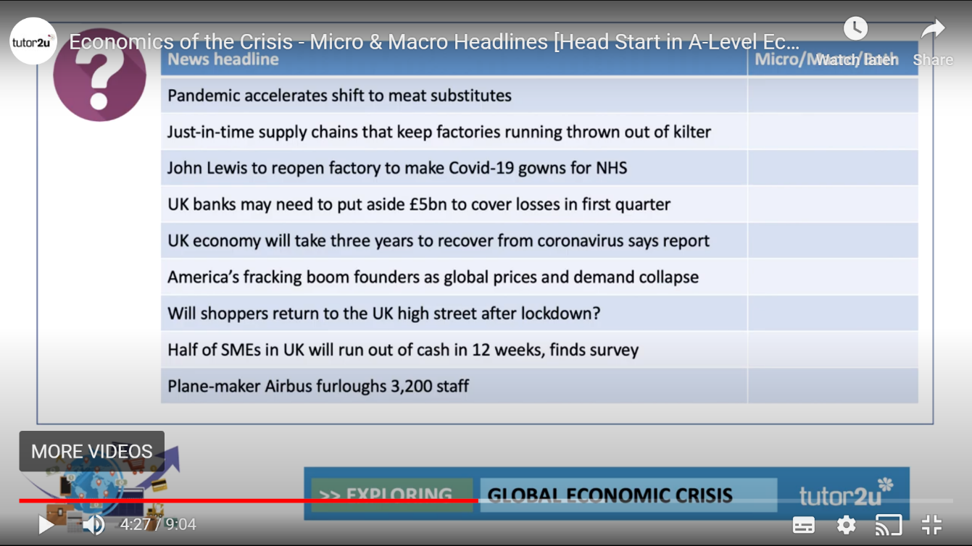
- Here are some more - again, micro, macro, or both

Meat substitutes -
Just in Time supply chains -
John Lewis -
UK Banks -
UK economy three years to recover -
US Fracking -
Shoppers return? -
SMEs running out of cash -
Airbus furloughs -

- The third video is on the changing world economy, and again is consolidation of what we have been studying before. Stop the video at 2:18 Emerging countries have been categorised by Economists into the first group (BRICs), and a second group (MINTs) - Who do you think those countries are?

B
R
I
C

M
I
N
T

- Stop the video at 3:50 - can you name the three countries with the highest GDP per capita in the world?

1.

2.

3.

- This is harder - stop the video at 4:24 -can you name the three countries with the lowest GDP per capita in the world?

1.

2.

3.

- What factors do you think have caused the massive chasm between the countries with the highest and lowest GDP per capita?

- Do you think the pandemic will accelerate the shift of economic power and influence eastwards quicker?

- What the BBC news report on Coronavirus’s impact on the Global economy. Explain why consumer and business confidence is so important to any possible recovery - whatever the governments do?

Consumer confidence -

Business confidence -

- The BBC news report shows the impact on developing countries - to what extent should a country like the UK look after itself before it worries about developing countries? Should we be giving aid to developing countries when we will come out of the pandemic with so many problems ourselves?

