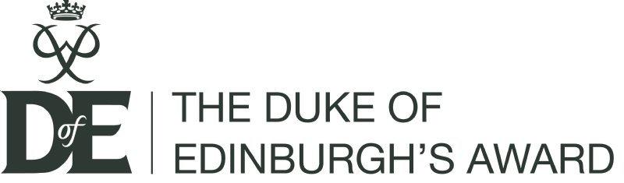
I …………………………………………………………………………. Understand that as part of the Duke of Edinburgh Bronze Award I am expected to undertake 3 months volunteering, 3 months of physical activity and 3 months of learning a new skill as well as completing a 15mile self sufficient assessed expedition in 24 hours
Signed: Date:
I am applying for a place on the Duke of Edinburgh Bronze Award because…
Hobbies & interests:
Name: Form:

